Bangladesh University of Engineering and Technology

Department of Computer Science and Engineering

**CSE 316**

Microprocessors, Microcontrollers, and Embedded Systems Sessional

**Experiment 1**

**AVR Microcontroller: Use of Polling for Digital IO.**

**GOAL:**

Use ATmega32 microcontroller to implement a 4 bit up-down counter.

**EXPERIMENTAL TOOLS AND MATERIALS:** ATmega32, USBASP programmer, Trainer Board, Wires, Avr Studio, Extreme Burner, two push buttons, two 10kΩ resistors (1kΩ resistors should work fine too)

**EXPLANATION OF PRINCIPLES:**

Push buttons and LEDs will be used to do input-output. Polling will be used to detect the button press.

**PROCEDURE:**

1. Connect two active high push buttons to two pins of ATmega32 (according to instructions given by the teachers during the lab).
2. Connect 4 LEDs to PORT A (lower 4 bits)
3. Write a C program to implement a counter. The 4 LEDs will be used to show the count and the  
   the counting function will be specified by the teachers. Pressing one button will count up while pressing the other button will count down. Use a polling approach to detect button presses.

**MISCELLANEOUS:**

1. Connect the buttons according to the following diagram:  
   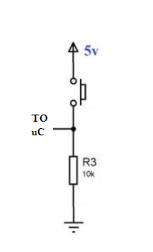  
   For more details refer to:   
   <https://electrosome.com/push-button-switch-atmega32-microcontroller-atmel-studio/>
2. Some pins of PORTC can not be used for I/O directly. First the JTAG has to be turned off.   
   One way is to uncheck the JTAG box while writing the fuse bits, the second is to write a 1 to the JTD bit twice consecutively. MCUCSR = (1<<JTD);   
   For more details refer to:   
   http://www.avrfreaks.net/forum/jtag-enablingdisabling-atmega32-and-fuse-settings-solved
3. You do not need to bother about FUSE bits. By default it is set to: E199  
   If the JTAG Interface is disabled it will be set to: E1D9. You can calculate fuse bit from this online tool: <http://www.engbedded.com/fusecalc/>

Bangladesh University of Engineering and Technology

Department of Computer Science and Engineering

**CSE 316**

Microprocessors, Microcontrollers, and Embedded Systems Sessional

**Experiment 2**

**Basic Bicolor LED matrix control with ATmega32: static, flash, and rotating display.**

**GOAL:**

To understand basic bicolor LED matrix control in order to generate different characters/symbols.

**EXPERIMENTAL TOOLS AND MATERIALS:** ATmega32, BiColor LED matrix, USBASP programmer, Trainer Board, Wires, Avr Studio, Extreme Burner.

**EXPLANATION OF PRINCIPLES:**

The experiment has three parts. First, you have to show a symbol in the LED matrix. **The symbol will be assigned by the lab teachers during the experiment.** In the second part, you will have to flash the same symbol, i.e., for some time the symbol will be shown and then it will disappear for some time before it reappears again, and so on. In the last part of the experiment you will left/right rotate the symbol. **The direction will be assigned by the lab teachers during the experiment.** The bicolor LED can show symbols either in green or red. **The color will also be assigned during the experiment.** You can connect the bicolor LED matrix to any of the ports of your choice.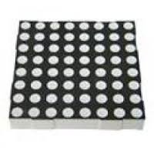

**LED Matrix Basics:**

The LED matrices used in the labs are 8x8 and bicolor. Each position (i.e., LED) can glow in green or red.

There are 24 pins in total to select which LED(s) we want to light up. 8 of the pins are used to select the row(s), while the remaining 16 pins are used to select the column(s) (The notion of row and columns are only artificial and depends on the way we consider the orientation of the LED matrix. Rotating the matrix by 90 degrees will alter the orientation. However we will use a fix orientation which is described later in this section). Among these 16 pins, 8 pins are used for lighting the LEDs red while the other 8 pins are used if we want to light the LEDs green. LED matrices can be oriented in two flavors: common (row) anode and common (row) cathode. The difference between these two configurations is how we light up a LED. With common anode orientation, positive voltage is attached to rows and ground to columns. With common cathode, the connections are reversed. In our experiments we will use the common anode orientation. 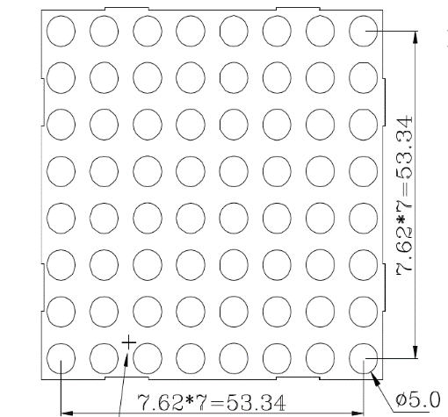

The pin diagram of the bicolor LED matrix is given below. The pin orientation depends on how you orient the matrix. Hold the LED matrix in such a way that the pins are towards you and the LEDs are at the opposite side (i.e. you are looking at the back of the matrix). Make sure the pins at the top and bottom of the matrix rather than on the sides. Finally make sure that the top of the matrix has a couple of outward extensions (bottom will then have inward extensions, the extensions can be seen in the schematic).

|  |  |  |  |  |  |  |  |  |  |  |  |
| --- | --- | --- | --- | --- | --- | --- | --- | --- | --- | --- | --- |
| Row4 | R4 | G4 | Row3 | R3 | G3 | Row2 | R2 | G2 | Row1 | R1 | G1 |
|  |  |  |  |  |  |  |  |  |  |  |  |
| Row8 | R8 | G8 | Row7 | R7 | G7 | Row6 | R6 | G6 | Row5 | R6 | G5 |

*Text side here - Upside Down*

**Description of pins:**

1) Rows are anode (+ve is to be given). Rows are numbered from up to down.

2) Columns are cathode (GND is to be given). Columns are numbered from left to right (Assuming this time you are facing the LED (front side of the matrix)).

3) RowX denotes row number.

4) GX is used to light up green LEDs in column X.

5) RX is used to light up red LEDs in column X.

For example, if we want to light the 2nd column of 3rd row with red, we will have to connect VCC to Row3 pin and GND to R2 pin.

**Showing a symbol in dot matrix:**

Typically multiplexing is used to display arbitrary patterns with led matrices. Multiplexing is sometimes also called scanning. It scans rows (usually from up to down) and lights selected LEDs only in one row at a time following these steps:

1. Turn on only the topmost row (i.e., provide +5V)
2. Turn on the necessary columns of the topmost row by connecting the corresponding column pins to ground. This lights up the selected LEDs in the topmost row.
3. Do steps 1 and 2 one by one for all rows and keep repeating.

If you do this slowly, you would see the LED rows turning on one after another. However, if it is done fast enough, human eye will see the whole pattern together. This phenomenon is called persistence of vision.

The amount of time you light up one row, before lighting up the next one is very crucial for the symbol to be displayed properly. Usually you will light up one row and then create a delay. After the delay is over you will light up the next row. If this delay is too long, one will see the rows being light up one after another and the illusion of displaying the whole symbol at once will not work. On the other hand, if the delay is very small, the LEDs will not get enough time to glow fully. Hence, the symbol will look less bright. **In the experiment you will have to find a near optimal delay on trial and error basis, so that the symbol is displayed bright and clear.**

**Why multiplexing:** There are 64 bicolor LEDs in a dot matrix, without multiplexing we would have needed 128 different pins to operate a single dot matrix!!!! Using multiplexing technique we can still operate it with only 24 pins.

**PROCEDURE:**

1. Connect the bicolor LED matrix to the ATmega32 according to instructions given by the teachers during the experiment.
2. Write a C program to implement each of the three parts of the experiment, **i.e., static display, flash, and rotating display** one after another. After finishing each part show it to the lab teacher.

**MISCELLANEOUS:**

1. Further details on working with LED matrices: <https://www.appelsiini.net/2011/how-does-led-matrix-work>
2. The power provided by USBASP may not be enough to drive the LED matrix. You can consider using external power source, e.g, the power source of experiment boards you used in DLD experiments and Motor experiment of this course.
3. Some pins of PORTC can not be used for I/O directly. First the JTAG has to be turned off.   
   One way is to uncheck the JTAG box while writing the fuse bits, the second is to write a 1 to the JTD bit twice consecutively. MCUCSR = (1<<JTD); MCUCSR = (1<<JTD);   
   For more details refer to:   
   http://www.avrfreaks.net/forum/jtag-enablingdisabling-atmega32-and-fuse-settings-solved
4. You do not need to bother about FUSE bits. By default it is set to: E199  
   If the JTAG Interface is disabled it will be set to: E1D9. You can calculate fuse bit from this online tool: http://www.engbedded.com/fusecalc/

Bangladesh University of Engineering and Technology

Department of Computer Science and Engineering

**CSE 316**

Microprocessors, Microcontrollers, and Embedded Systems Sessional

**Experiment 3**

**Basic use of ADC and LCD module with ATmega32.**

**GOAL:**

To understand the basic working principle of ADC and the LCD module.

**EXPERIMENTAL TOOLS AND MATERIALS:** ATmega32, 16×2 character LCD module, USBASP programmer, Trainer Board, Wires, Avr Studio, Extreme Burner, Potentiometer.

**BASIC DESCRIPTION:**

In this experiment you will have to generate a variable voltage from 0 to 4V using a potentiometer. You will measure this voltage using ADC and display the voltage in the LCD segment. You will also continuously monitor the voltage using a voltmeter. You should use the DVM (digital volt meter) from the trainer board. We will change the voltage using the pot and the reading of ADC from the LCD segment should be close to the value shown in the DVM.

**LCD Module Basics:**

You should check out [this](https://electrosome.com/interfacing-lcd-atmega32-microcontroller-atmel-studio/) tutorial. You will be using the 4 bit mode. Essentially, you will use their library file and connect your LCD module according to the given diagram. You do not need to use crystal. The connections of VSS, VDD, VEE, and D0-D3 are also not needed. In fact the available LCD modules in  
the lab (and also in the market) have these connections built-in. So you do not need to worry about those. The connection summary is given in the following table.

|  |  |
| --- | --- |
| LCD Module Pin | ATmega32 Pin |
| RS | PC6 |
| RW | GND |
| E | PC7 |
| D4-D7 | D4-D7 |
| VCC | 5V |
| GND (both) | GND |

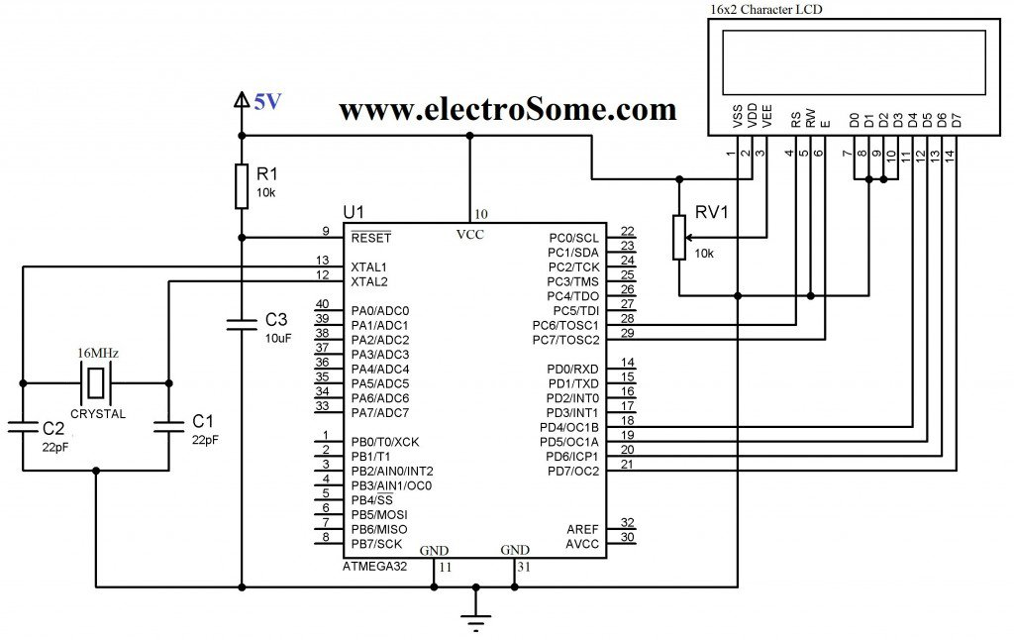

**Figure:** Circuit diagram of the LCD module. You do not need to use crystal. The connections of VSS, VDD, VEE, and D0-D3 are also not needed. In fact the available LCD modules in the lab (and also in the market) have this connections built-in. So you do not need to worry about those.

**ADC Basics:**

The basics were covered in the theory class. Do necessary calculations according to your clock speed and configuration. If you use the internal 5V as ADC source. You will have to connect AVCC (PIN30) to 5V and GND (PIN 31 and PIN 11) to 0V. You can connect the AREF pin (PIN32) to a capacitor e.g., 10μF or, 1μF, however it is optional.

**PROCEDURE:**

1. First create a 4V source from the trainer board. Then create a variable voltage source of 0-4V using the potentiometer. Ensure the potentiometer is working by checking its output in the DVM of trainer board.
2. Connect the LCD module to your microcontroller. Remember to use the power source of trainer board. The USB ASP will not be able to drive the LCD module. Write the necessary code to display a simple string, e.g., “Patience!!” to check the LCD module is working. Show it to the lab teachers.
3. Complete the necessary ADC connections and display the variable voltage both in the DVM and your LCD module.

**MISCELLANEOUS:**

1. The USB ASP may not be able to drive the LCD module properly. You should use the trainer board.
2. The connection to the LCD segment is crucial. Without proper connection it will not work. Upon given VCC and GND and the backlight switch on, the LCD module should lit the backlight on and show a blank screen. Using female to male jumper wires to connect the LCD module can be subject to loose connection. Setting the LCD module directly to the breadboard seemed to work better.
3. There is a pot in the LCD module. You can use it to adjust the contrast.
4. Never input a voltage greater than 5V to your ADC input.
5. Some pins of PORTC can not be used for I/O directly. First the JTAG has to be turned off.   
   One way is to uncheck the JTAG box while writing the fuse bits, the second is to write a 1 to the JTD bit twice consecutively. MCUCSR = (1<<JTD); MCUCSR = (1<<JTD);   
   For more details refer to:   
   <http://www.avrfreaks.net/forum/jtag-enablingdisabling-atmega32-and-fuse-settings-solved>
6. You do not need to bother about FUSE bits. By default it is set to: E199  
   If the JTAG Interface is disabled it will be set to: E1D9. You can calculate fuse bit from this online tool: <http://www.engbedded.com/fusecalc/>

This is a tentative list of instruments. Quantity may vary.

* Atmega32 - 6 ones
* Atmega Burner or USBASP programmer
* Breadboard (1 ps)
* Jumper Wires (male-to-male, male-to-female, female-to-female) (30-40 ps each)(you will probably need it in large numbers for project)
* Push Buttons (5 ps)
* LEDs (5-10 ps)
* Resistors (220 ohm, 1k ohm, 2.2k ohm, 10k ohm) (10-20 ps each)
* Bicolor (red-green) 8x8 LED matrix

* 16x2 LCD display module (Caution: you have to connect male connector row with LCD display, male connector row is explained below)

* Male connector row

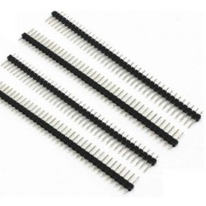

You need to solder male connector to the LCD display. Do not try to solder if you are not somewhat expert in this. Yo’u can ask other expert people to do that for you. Here’s a video <https://www.youtube.com/watch?v=E9NIN49iiCc>. Or, if you can buy an LCD display with male connector attached to it, that would be great.

* Potentiometer

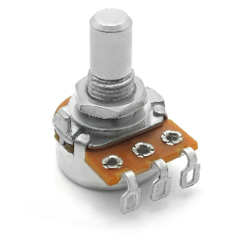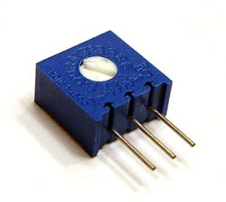

* Multimeter (This is not necessary but very appreciated. You can buy 1 piece for a whole group.)

